Bitmap Index Demo

Login as DBA.

Remove all the cached data from buffer, all the sql statements from shared pool and set the tracing on by executing the following 3 commands.

SQL Plus Editor:

Alter system flush buffer_cache;
Alter system flush shared_pool;
SET AUTOTRACE ON

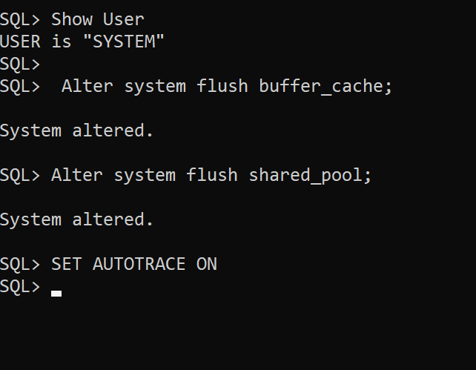

The Sales table of user Scott has 30,000 rows totally and of each color type approximately 5000 rows are there.

Let’s execute a select statement on Scott user’s Sales table to get the number of records (i.e., number of transactions done) for a one particular color Blue when there is no bitmap index created.

select count(*) from Scott.Sales
where color = 'Blue';

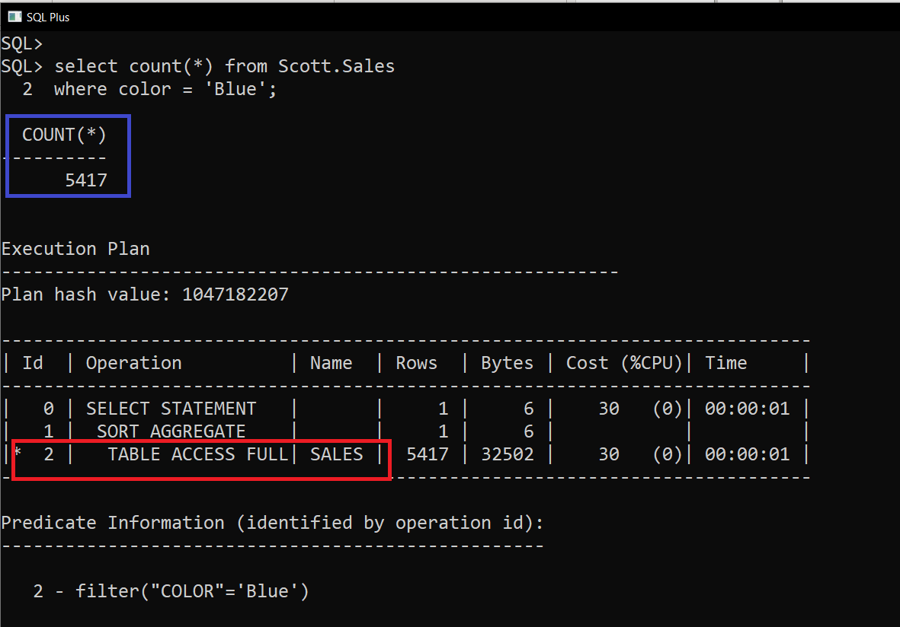

Notice that a full table scan has happened, which will slow down the query execution.

Again, remove all the cached data from buffer, all the sql statements from shared pool and set the tracing on by executing the following 3 commands.

Alter system flush buffer_cache;
Alter system flush shared_pool;
SET AUTOTRACE ON

Now let’s create a bitmap index on the column color of Scott’s sales table.

Create Bitmap Index Scott_Sales_Color
on Scott.Sales(Color);

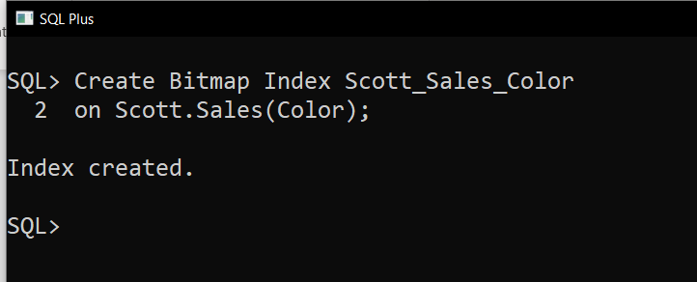

After indexing the column again reset memory and environment

Alter system flush buffer_cache;
Alter system flush shared_pool;
SET AUTOTRACE ON

Now execute the same select statement:

select count(*) from Scott.Sales
where color = 'Blue';

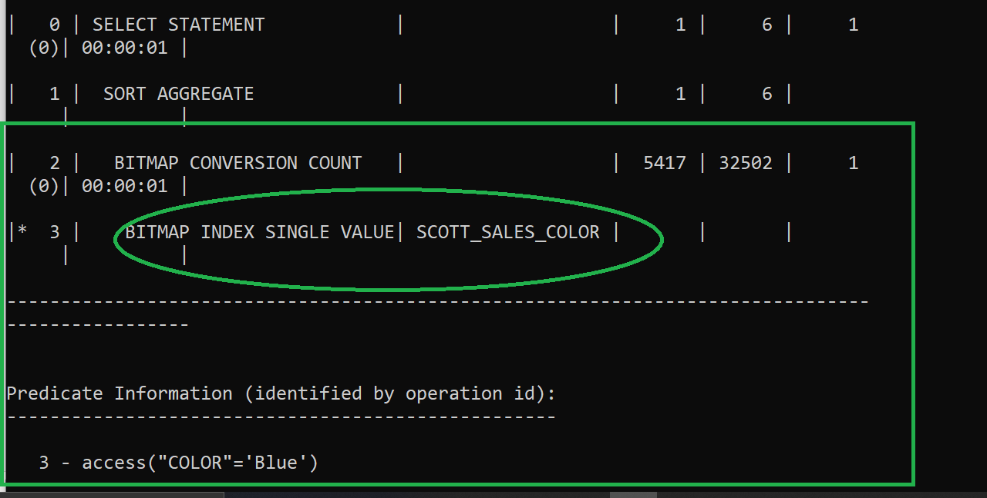

Notice Now the Full Table Scan has not happened!! Rather it has scanned through the bitmap index values!!!
Bitmap keep the track of null values as well.

Let’s make some records’ color null

Update Scott.Sales
set color = null
where customerid in (19, 197); -- 291 rows

Alter system flush buffer_cache;
Alter system flush shared_pool;
SET AUTOTRACE ON

select count(*) from Scott.Sales
where color is null;

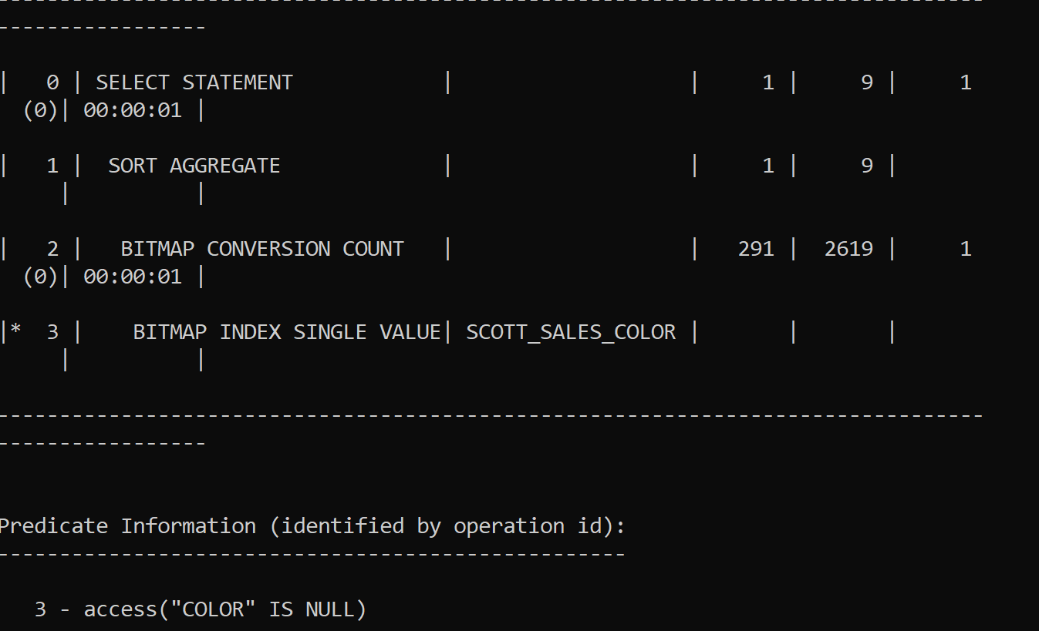

rollback;

For non existing values of color in where clause as well it will do index search!

Alter system flush buffer_cache;
Alter system flush shared_pool;
SET AUTOTRACE ON

select count(*) from Scott.Sales
where color = 'Magenta';

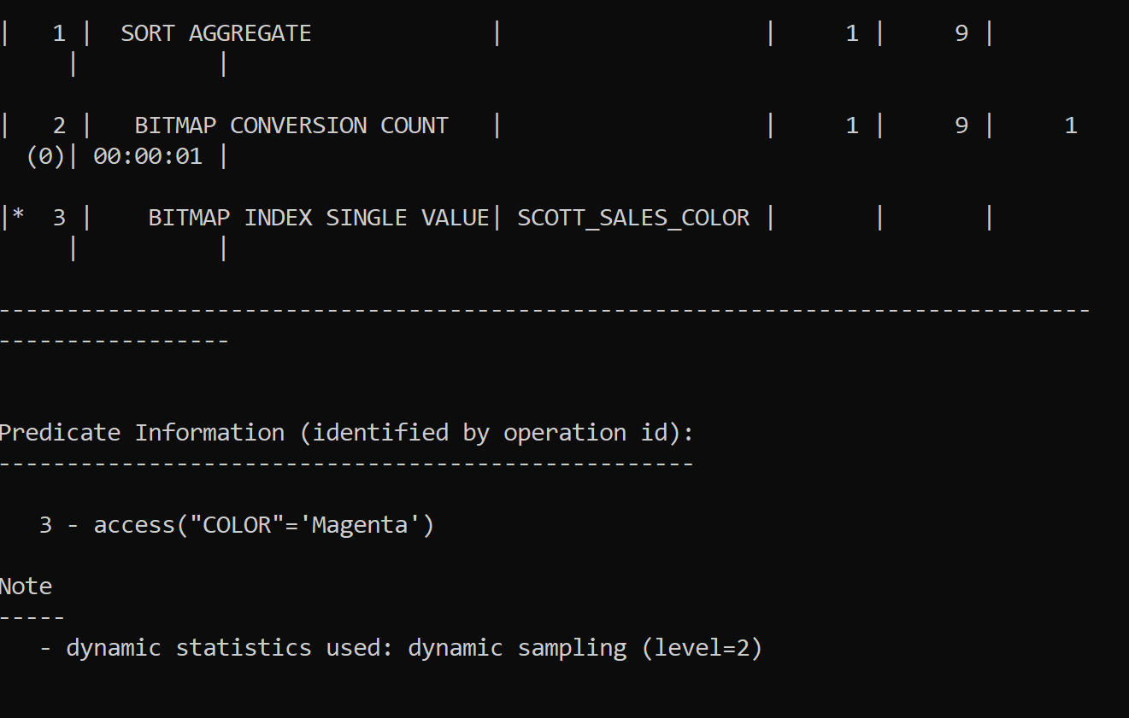

In Operator: Note always In values get converted into separate OR conditions

Alter system flush buffer_cache;
Alter system flush shared_pool;
SET AUTOTRACE ON

select count(*) from Scott.Sales
where color in ('Black', 'White');

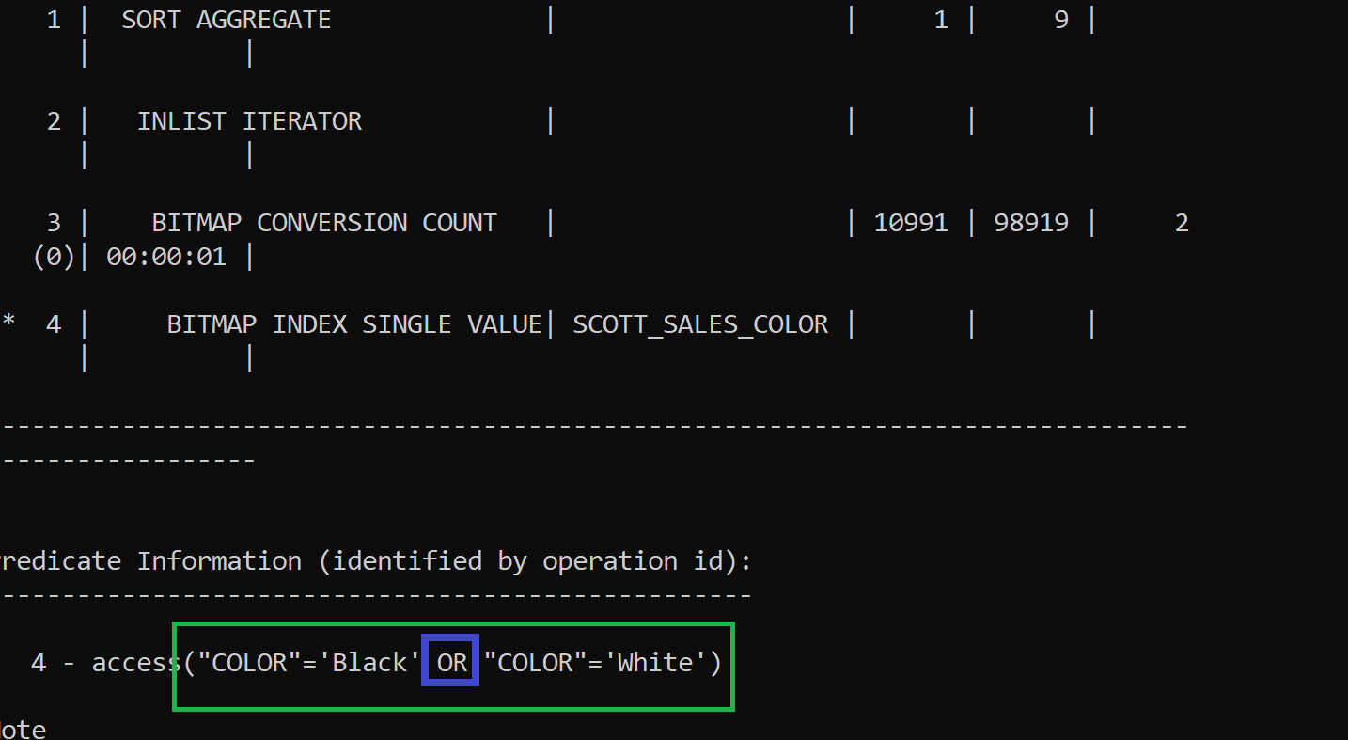

SQL Developer Editor

Alter system flush buffer_cache;
Alter system flush shared_pool;
SET AUTOTRACE ON

select count(*) from Scott.Sales
where color Like 'B%';

Explain Plan:

When you execute an EXPLAIN PLAN statement, Oracle generates a theoretical execution plan for your SQL query. This plan represents how Oracle thinks it will execute the query based on the available statistics and optimizer inputs. It provides details about the query execution steps, access paths, join methods, and estimated costs

Auto Trace:
Auto Trace, on the other hand, shows the actual execution plan used by Oracle when running the query.

When you enable Auto Trace in SQL Developer, it executes the query and captures the real execution plan along with resource usage statistics (such as CPU time, I/O, and memory).

Auto Trace Output:
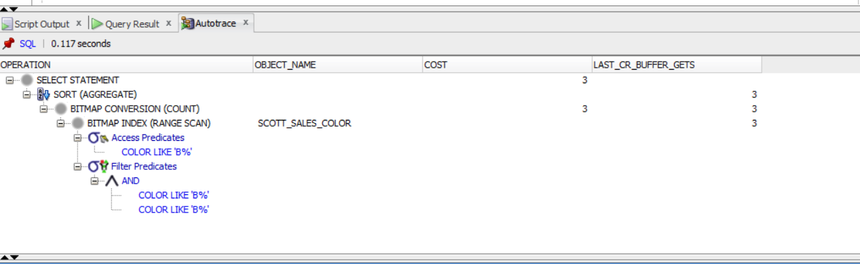

Explain Plan Output:

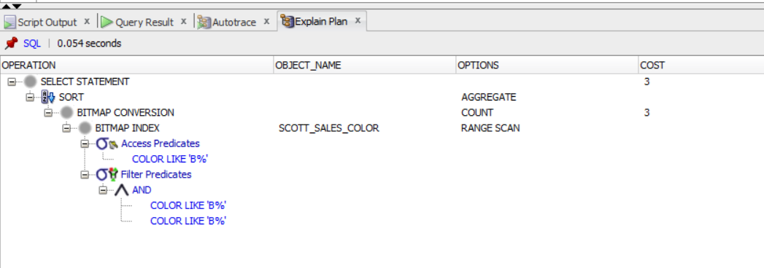

Note The above screenshota are taken from SQL Developer after enabling Auto Trace and Explain Plan icons as shown next

